University of Brighton
School of Environment and Technology
GBM02 Environment Placement

Site Suitability Analysis for Woodland Opportunity in Lewes District
  - A site suitability assessment of the potential opportunities for woodland establishment within the Lewes District, using Nidderdale AONB Woodland Opportunity Plan as a framework.

Contents
Introduction 3
Methodology 4
Data Collation and Processing 4
Boolean Identification of Constraint Areas 4
Weighted Sum for Site Suitability Evaluation 5
Boolean Identification of Socially Benefitting Regions 7
Results and Discussion 9
Conclusions and Recommendations 18
Appendix 19
Appendix A 19
Data Sources 19
Tools Used in the Report 21
Appendix B 22
Outputs of Constraint Layers 22
Outputs of Negatively Weighted Layers 26
Outputs of Positively Weighed Layers 29
References 33

Introduction

Tree planting initiatives are reported to have several environmental benefits such as combatting climate change, regulating hydrology, improving water quality, sequestering carbon, and conserving biodiversity (Newmark et al., 2017; Bastin et al., 2019; Griscom et al., 2017). With billions invested into tree planting schemes worldwide, it is imperative that the location of woodland establishment, and its methods, are well thought through to ensure success and avoid potential negative consequences (Holl & Brancalion, 2020). Unintentional negative impacts could include reduced water supply, destruction of native grasslands, spreading invasive species, displacement of farmland, and increased deforestation (Holl & Brancalion, 2020).
With £640 million invested in planting more than 40 million trees in England (Ares & Uberoi, 2020), there is a great need to know what the ‘right tree in the right place’ looks like. This report sets out to create a tool to assist in the identification of areas of opportunity for woodland within the Lewes district. The GIS approach of spatial multi-criteria evaluation (SMCE) enables a practical resolution to complex decision-making problems (Kiker et al., 2005). The Woodland Trust’s Nidderdale AONB Woodland Opportunity Plan (2020) was used as a framework for the project.
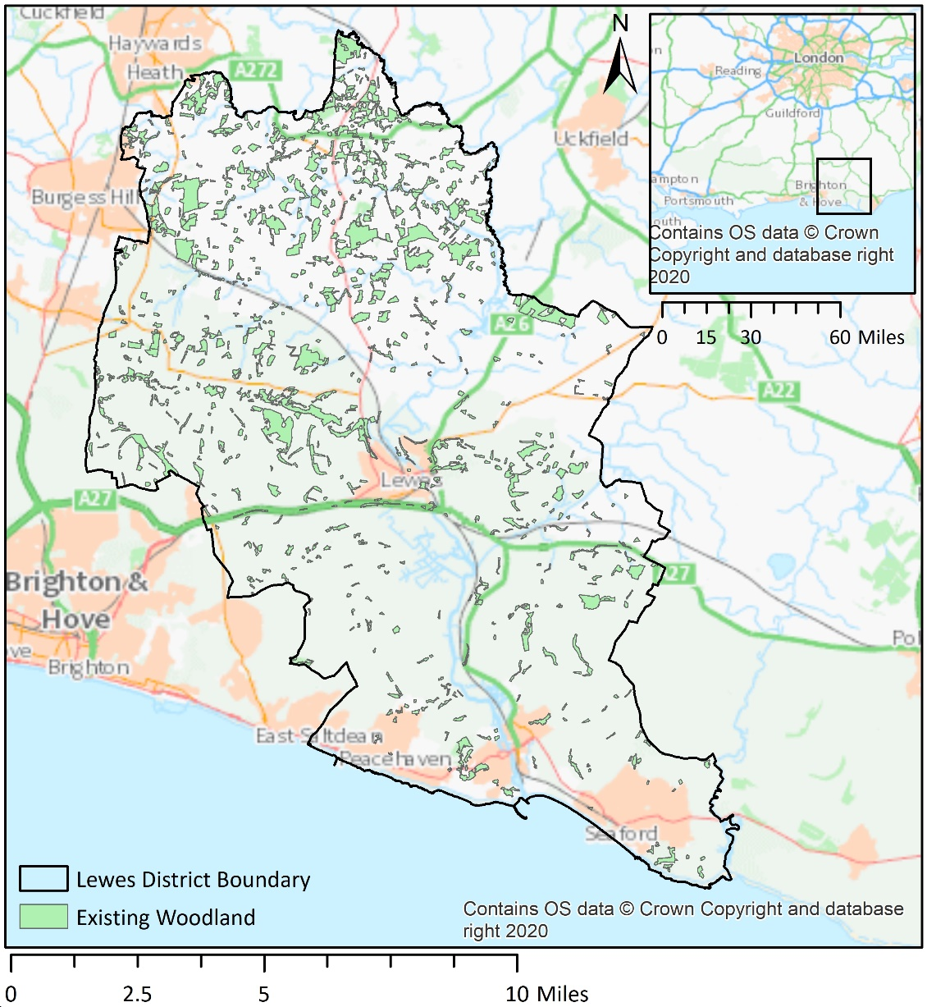
Figure 1 – The study region (Lewes District) showing existing areas of woodland and with a small context map to show the extent of the study region in relation to London, Brighton and Hove, and Portsmouth.

Methodology

The adopted approach consisted of two main stages, firstly identification of constraint areas, and secondly assessing the suitability of non-constraint areas, also referred to as opportunity areas. Opportunity areas are scored based upon a number of negatively and positively weighted criteria. Constraint areas are considered to be places that woodland establishment would be unsuitable, either due to physical constraints, or the negative impacts of tree establishment would greatly outweigh the benefits. Opportunity areas take a more nuanced approach to consider the benefits and disadvantages to woodland establishment. Such evaluation of many potentially conflicting criteria is made possible using multi-criteria decision-making (MCDM), often leading to appropriate solutions for development (Ishizaka & Labib, 2011).

Data Collation and Processing

All data (Tables 1 to 3) were individually processed and converted to raster layers (using the Euclidean Distance tool), with 25m cell sizes, and projected (Appendix A) in the coordinate system British National Grid (BNG). This step enables all the datasets to align correctly with one another. All data were clipped within 3km of the Lewes district, therefore criteria with buffers that lay just outside of the district boundary will also be included, to create a more accurate picture, with no skewing of edges.

Boolean Identification of Constraint Areas

Constraint areas were identified by using the Raster Calculator (Appendix A) using the criteria listed in Table 1. The parameters of each criterion were assessed using a bilinear scale, 0 represents unmet criteria and 1 represents the criteria has been met, therefore a constraint area. The layers created from this were then combined using the Boolean function of Fuzzy Overlay “OR” (Appendix A) giving a rigid solution, showing all areas where criteria have been met, or not, in a singular layer. The criteria used for constraints are within Table 1.
Constraints Criteria | Justification
Extent of PHI | To protect the biodiversity of priority habitats
Extent of Scheduled Ancient Monuments (SAM) | To protect the cultural heritage of SAM
Extent of World Heritage Sites (WHS) | To protect the cultural heritage of WHS (None within Lewes)
Extent of Local Geological Sites (LGS) | To protect the cultural heritage of LGS
Extent of Archaeological Notification Area (ANA) | To protect the cultural heritage of ANA
Extent of Buildings | Tree planting not feasible
Extent of River Network | Tree planting not feasible
25m Buffer to Ponds | To reduce risk of eutrophication
15m Buffer to Veteran Trees/TPO | To protect veteran or important trees
Extent of Existing Woodland | Tree planting not feasible
Extent of Agricultural Land Classification (ALC) Grade 1 and 2 | To protect productive agricultural land for food
Extent of Battlefields | To protect cultural and heritage assets
50m Buffer to Utility Infrastructure | Ensures a no dig buffer around important underground infrastructure
Table 1 – List of criteria used to create the constraint areas in the first stage of analysis. Data sources can be found in the appendix A.

Weighted Sum for Site Suitability Evaluation

The inclusion of multiple stakeholders when addressing spatial planning, means that different levels of understanding of different aspects of the same issue can be collated from their individual experiences (Simao, Densham & Haklay, 2009). This highlights the flexibility of MCDM as a method as it allows for the inclusion of stakeholder’s expertise in the decision-making process (Baban & Parry, 2001). All negative and positive criteria were also assessed using a bilinear scale to normalise each criterion; weights are then assigned to every normalised criterion, ranging from -5 to +5. All criteria were finally combined using the Weighted Sum tool (Appendix A), where the resultant maximum values identify areas of high opportunity and minimum values represent areas of low opportunity that should be treated cautiously. Weightings typically followed those used by the Nidderdale AONB Woodland Opportunity Plan, with minor changes due to local knowledge of Lewes district. Two versions of the Weighted Sum were used to compare the effects of including social factors as criteria, this was done cautiously as to not mask out environmental factors. Although both versions were effective (Figures 3 to 6), it was decided that overlaying social layers would be preferable, to be certain that other important factors are not being overlooked.

Boolean Identification of Socially Benefitting Regions

In order to create more sophistication in overlaying the social layers, Raster Calculator (Appendix A) was used to combine social criteria using the function “+” to produce an output showing how many of the three social criteria had been met. Raster Calculator (Appendix A) was then used to identify regions that met at least two of the social criteria. This layer can then be used as further justification for woodland establishment site selection.

Negative Criteria | Justification | Nidderdale Weightings | Used Weightings
15-50m Buffer to Veteran Trees/TPO | To protect veteran or important trees | -5 | -5
Extent of Traditional Orchards | To protect biodiversity and heritage | -4 | -4
Extent of Pasture and Parkland | To protect biodiversity and heritage | -3 | -3
Extent of Local Wildlife Sites (LWS) | To protect biodiversity | -3 | -3
Extent of Special Protection Area (SPA) | To protect biodiversity (None within Lewes) | -2 | N/A
Extent of Special Areas of Conservation (SAC) | To protect biodiversity | -2 | -2
Extent of Site of Special Scientific Interest (SSSI) | To protect biodiversity | -2 | -2
150m Buffer to SAM | To protect SAM | N/A | -5
150m Buffer to LGS | To protect LGS | N/A | -5
150m Buffer to ANA | To protect LGS | N/A | -5
150m Buffer to WHS | To protect WHS (None within Lewes) | N/A | -5
Extent of Existing Conifer | For replacing with broadleaved trees to enhance biodiversity | -4 | -4
Table 2 – List of criteria used as the negatively weighted layers in the scored opportunity areas within the non-constraint zones. Data sources can be found in the appendix.

The methodology for weighting criteria closely follows the work of the Nidderdale AONB Woodland Opportunity Plan. The main difference in negatively weighted criteria (Table 2) is the inclusion of buffered SAM, LGS, and ANA, with just the extent of these sites being used as a constraint. This change was made based on recommendations from representatives of the Woodland Trust. Key differences in the positively weighted criteria (Table 3) are the inclusion of low-grade agricultural land, and a proxy for access with buffered A roads. In addition to this, hedgerows were given a reduced weighting as the data was a sample survey and therefore had sporadic coverage.
Positive Criteria | Justification | Nidderdale Weightings | Used Weightings
50m Buffer to Rivers | Reduce flow in riparian zone | 3 | 3
Extent of Flood Zone 2 and 3 | Flood mitigation - to slow water flow | 3 | 3
Extent of ALC Grade 4 | Fully utilising agricultural land that is not very productive | N/A | 2
Extent of ALC Grade 5 | Fully utilising agricultural land that is not very productive | N/A | 3
500m Buffer to A Roads | Improve access and reduce noise/air pollution | N/A | 2
150m Buffer to Hedgerows <150m long | Improved habitat connectivity | 1 | 1
150m Buffer to Hedgerows 150m - 500m Long | Improved habitat connectivity | 3 | 2
150m Buffer to Hedgerows >500m Long | Improved habitat connectivity | 5 | 3
50m Buffer to Ancient Woodland | Protective buffer for high value woodlands | 3 | 5
150m Buffer to Existing Woodland | Improved habitat connectivity | 5 | 5
350m Buffer to Existing Woodland | Improved habitat connectivity | 2 | 2
150m Buffer to LWS Woodland | Protective buffer for high value woodlands | 3 | 5
100m Buffer to Public Rights of Way (PROW) | Positive social impact on public access to woodlands | 1 | 1
Table 3 – List of criteria used as the positively weighted layers in the scored opportunity areas within the non-constraint zones. Data sources can be found in the appendix.

300m Buffer to Buildings | Positive social impact on public access to woodlands based on Access to Natural Greenspace Standards (ANGSt).
Indices of Multiple Deprivation (IMD) Deciles 1 and 2 | Positive social impact on public access to woodlands
Indices of Multiple Deprivation (IMD) Deciles 3 and 4 | Positive social impact on public access to woodlands
Table 4 - Social criteria used as additional justification of site selection.

Results and Discussion

Constraint areas covered 16513.266ha, leaving 43.91% (Table 4) of Lewes district as an opportunity area for woodland establishment (Figure 2). The criteria with the largest coverage of the constraint areas are the Priority Habitat Inventory which covers 7282.702ha (57.73% of the constraint area). The constraint criteria with the smallest area were the buffer of less than 15m to ancient and veteran trees, or trees with preservation orders (Table 5).

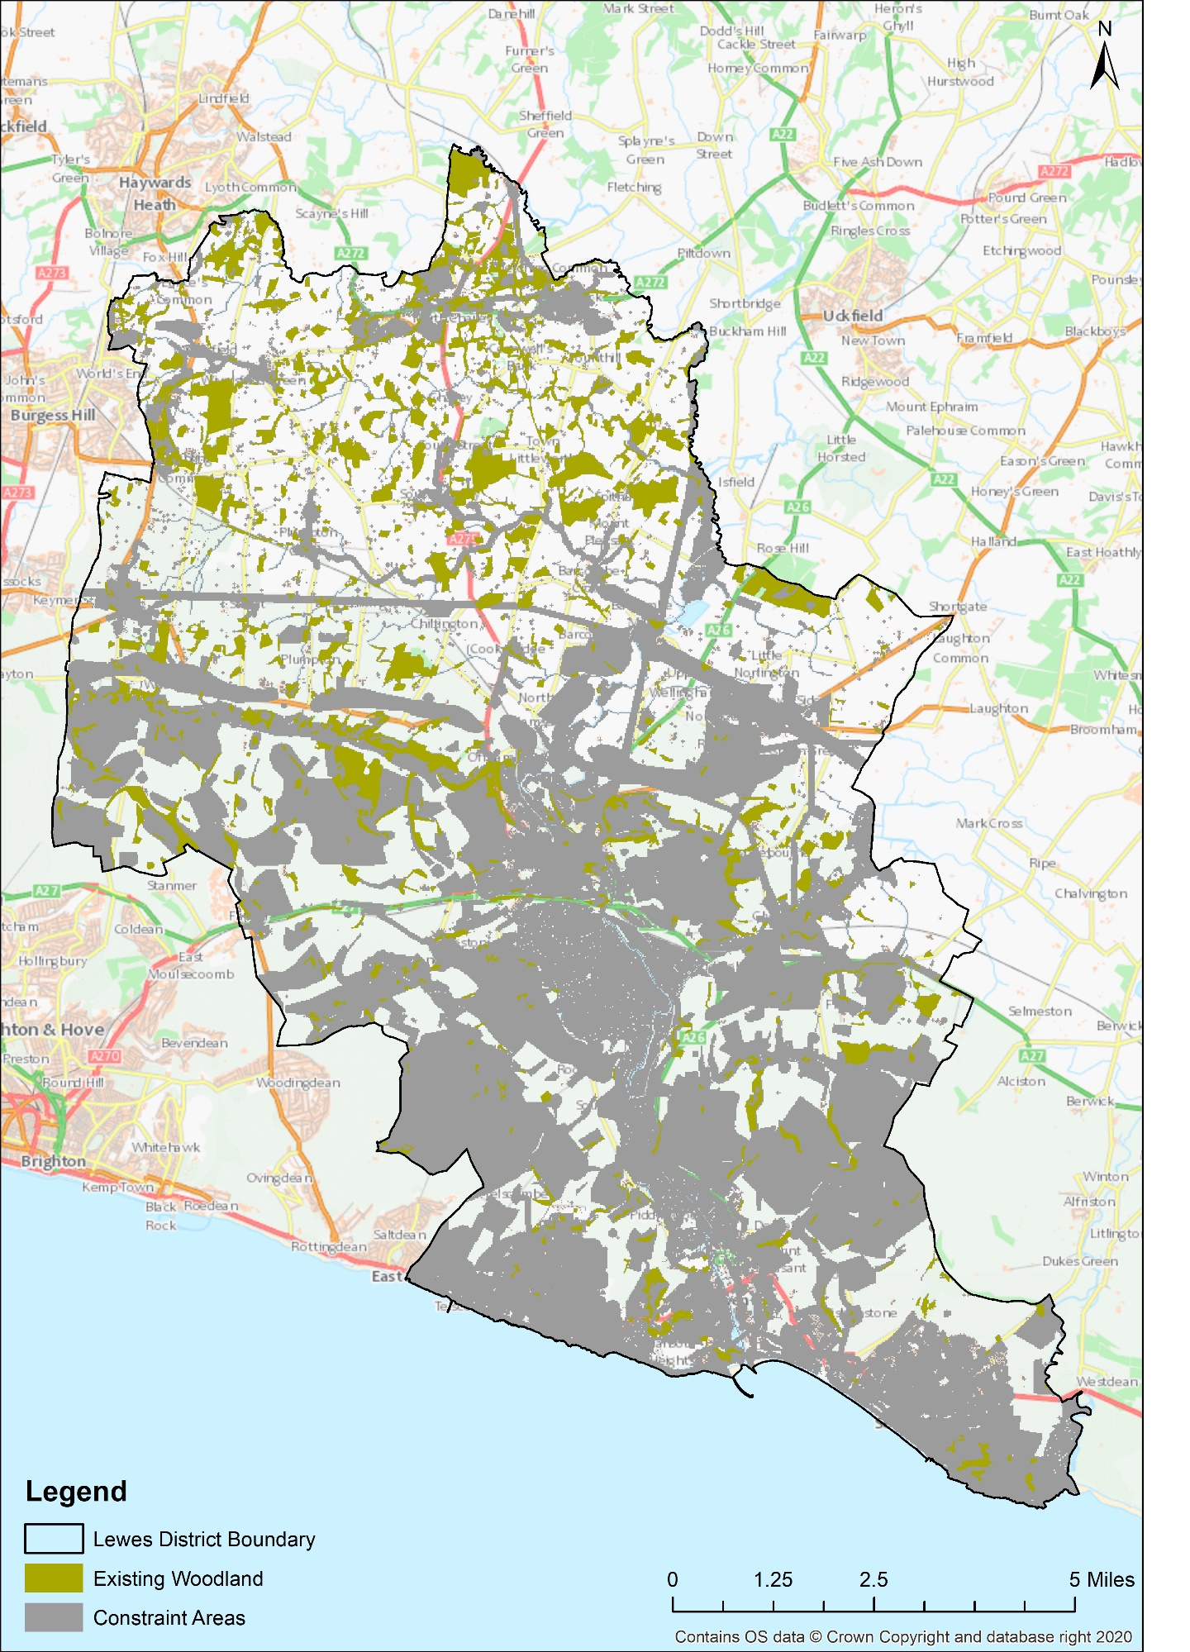
Figure 2 – the constraint areas (shown in grey) with existing woodland (shown in olivenite green) for the Lewes district, using criteria listed in Table 1.
 | Area (ha) | Percentage Cover of Lewes District (%)
Lewes District | 29441.271 | 100%
Constraint Area | 16513.266 | 56.09%
Opportunity Area | 12928.005 | 43.91%
Table 5 – Coverage of constraint and opportunity areas in both hectares and represented as percentages of the Lewes District.

 | Area (ha)
Extent of PHI | 7282.702
Extent of Scheduled Ancient Monuments (SAM) | 100.6005
Extent of Archaeological Notification Area (ANA) | 6929.777
Extent of World Heritage Sites (WHS) | N/A
Extent of Local Geological Sites (LGS) | 183.3629
Extent of Urban and Suburban Areas | 1370.451
Extent of Water and River Network | 403.9196
25m Buffer Ponds | 394
15m Buffer to Veteran Trees/TPO | 92.18046
Extent of Existing Woodland | 2952.007
Extent of Agricultural Land Classification (ALC) Grade 1 and 2 | 1297.875
Extent of Battlefields | 97.5
50m Buffer to Southern Water Infrastructure | 3196.022
Total | 16976.62
Table 6 – Coverage of individual constraint criteria in hectares for comparison of overall composition of the constraint layer.

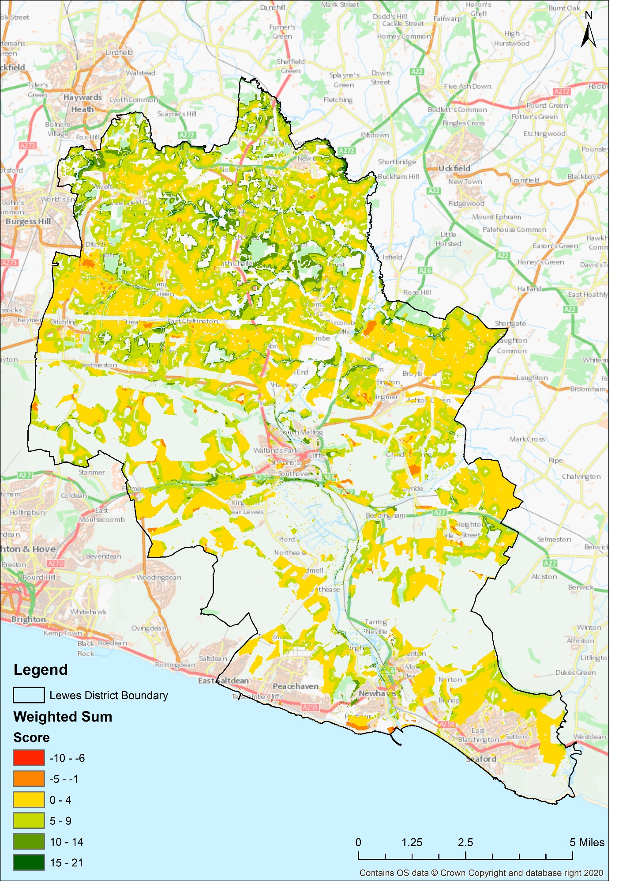
Figure 3 – Weighted sum to show a nuanced look at the areas of opportunity for woodland establishment in Lewes with constraint areas left blank.
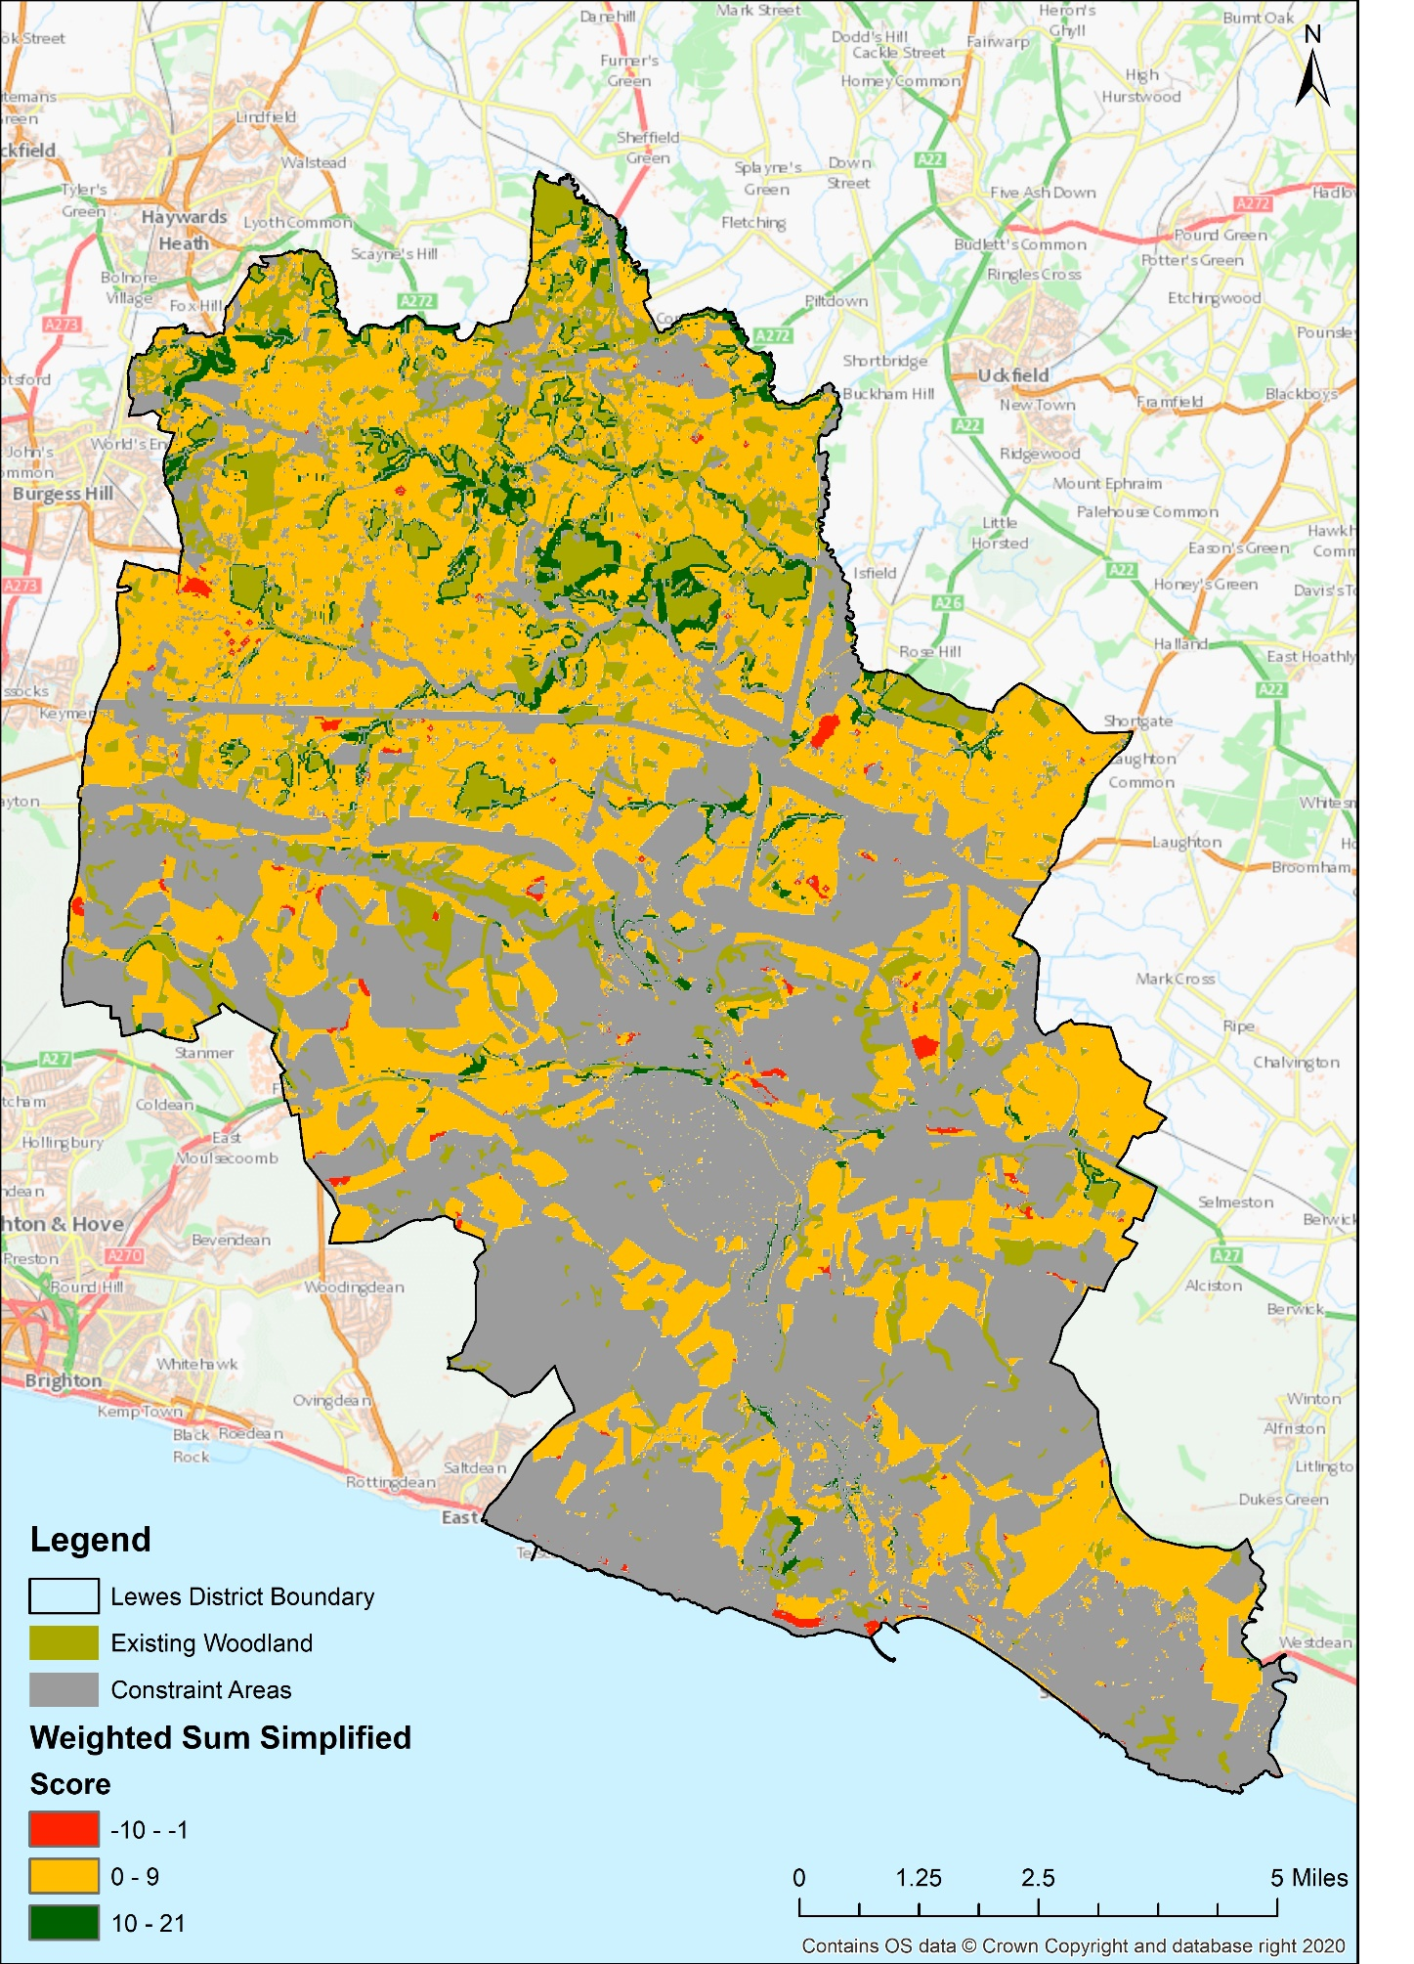
Figure 4 – Simplified map of weighted sum, showing levels of opportunity with a 'traffic light' system, overall negative scores in red (low levels of opportunity), low positive scores in amber (medium opportunity), and high positive scores in green (high levels of opportunity). Grey areas represent the constraint areas.
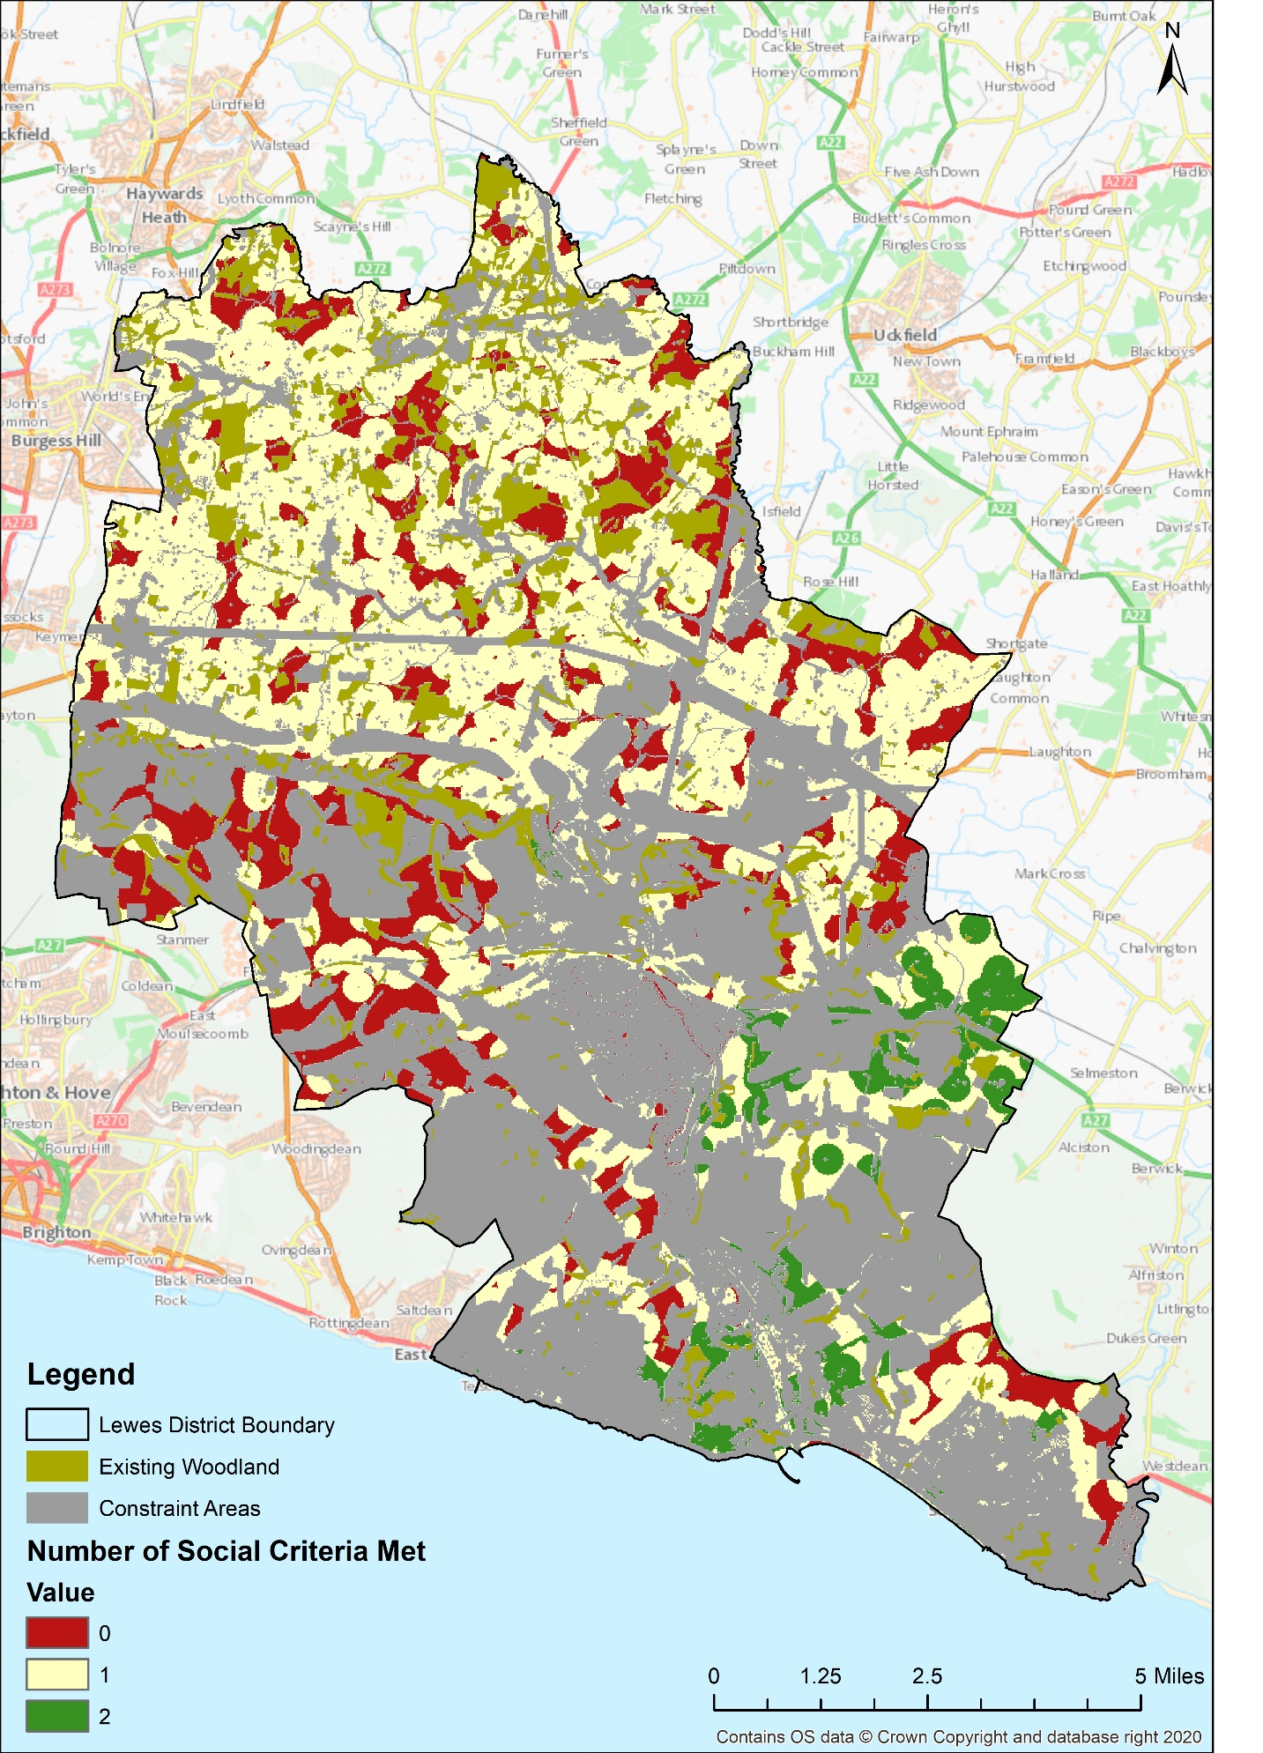
Figure 5 – Combination of social criteria (300m to buildings ANGSt, IMD deciles 1 and 2, and IMD deciles 3 and 4) showing how many social criteria are being met in which areas. Nowhere within the opportunity areas met all three of the social criteria.
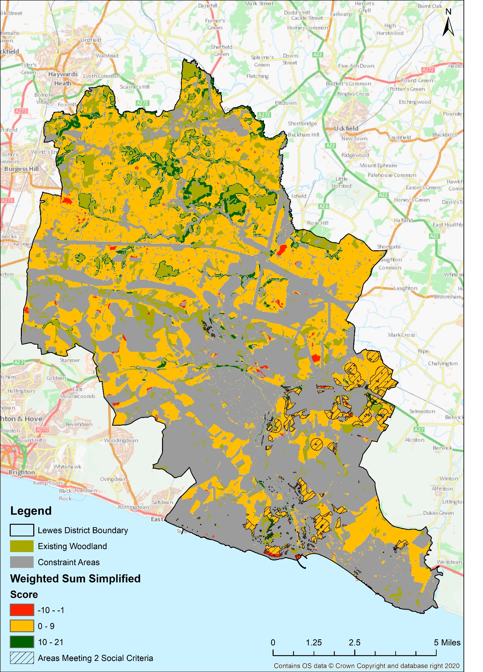
Figure 6 – Simplified weighted sum showing levels of opportunity with a 'traffic light' system, overall negative scores in red (low levels of opportunity), low positive scores in amber (medium opportunity), and high positive scores in green (high levels of opportunity), with added social layers. Grey areas represent the constraint areas. Areas meeting at least 2 of the social criteria are in circled in black and lined.
 | Lewes Weighted Sum (ha) | Percentage Cover of Opportunity Area (%)
Low | 183.625 | 1.42
Medium | 11727.875 | 90.72
High | 1016.375 | 7.86
Table 7 – Coverage of levels of opportunity in both hectares and as percentages of the non-constraint, opportunity areas.

The remaining 12928.005ha of Lewes had its potential for woodland establishment scored according to roughly 30 negatively and positively weighted criteria (ranked from -5 to +5). All sites identified for woodland establishment would need in-person ground truthing, however with a higher Weighted Sum score, sites can be treated with increased certainty that they would be suitable for planting.
Two versions of the opportunity mapping were produced, one with 6 classifications of opportunity to show a nuanced visualisation of the scores (Figures 3 and 4). The other version was further simplified into 3 classifications of opportunity (Figures 5 and 6. Areas resulting in an overall negative score could potentially have woodland established on, however these sites would need to be treated with extreme caution. High opportunity areas are considered to have a Weighted Sum of 10 or above as this depicts areas meeting at least 2 highly weighted positive criteria (or many lower weighted criteria).
The weighted sum resulted in 1016.375ha being identified with a high level of opportunity; these high opportunity areas tend to reside around existing woodland areas (Figure 4).
A downfall to these MCDM approaches is that it is not possible to know which layers are causing the resultant scores within the opportunity mapping (although all criteria layers separated out are in the Appendix B for further investigation). It was also a concern that including social factors may mask out important negative weighted factors. Therefore, by layering the social layers on top of the opportunity map, in order to locate areas with a score of 10 or higher within social criteria areas. Levels of opportunity with areas meeting at least 2 social criteria are displayed within Figure 6. Within regions that met two social criteria, there were 34.75ha of land with a score of 10 or above (Figure 7).
According to the Forestry Commissions Woodland Carbon Code, after 50 years a new native woodland has the carbon sequestering ability of 300-400 tonnes of CO₂ per hectare, and 400-500 tonnes after 100 years. Therefore, if the entirety of areas with high levels of opportunity had woodland established, then after 100 years it has the potential to store up to 508,187.5 tonnes of CO₂ for the weighted sum without social layers included. If the high opportunity areas meeting at least 2 criteria were planted on, then still 17,375 tonnes of CO₂ could be sequestered.

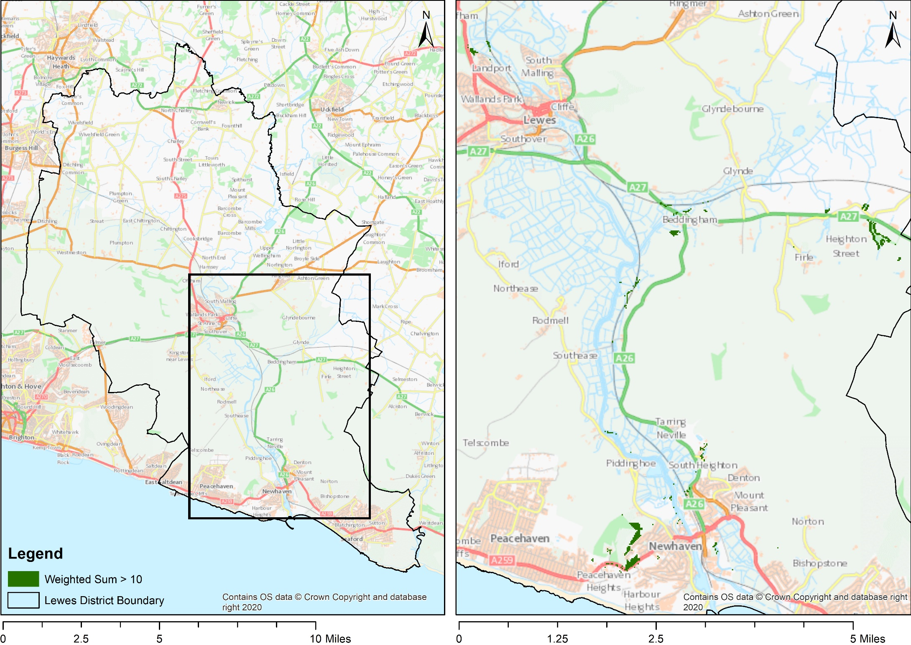
Figure 7 – Areas with a score of 10+ (High level of opportunity) which also reside within regions that meet at least two social criteria, shown within context of the overall study region on the right.

Conclusions and Recommendations

The results of this project have demonstrated the potential for a tool for evaluating the levels of opportunity for woodland establishment within the Lewes district. The opportunity mapping identified 42.85% of Lewes to be unsuitable for woodland establishment according to 13 constraint criteria. Areas with high opportunity spanned 1016.375ha. Using areas that meet at least 2 social criteria as an overlay, 34.75ha are identified to have high levels of opportunity. Establishing woodland on these socially benefitting, high opportunity areas would result in 17,375 tonnes of CO₂ being captured. These results have great importance for a number of applications. The outputs can be utilised in informing strategic planners, and those responsible for ‘climate action planning’ in local authorities, and Tier 1 local authorities that are responsible for preparation of ‘local nature recovery networks’ as per the Environment Bill, as well as allowing water companies to think strategically about how to fulfil their tree planting targets. Furthermore, the results are not only a useful tool for implementing practical work but also as a communications tool for local community groups and Non-Governmental Organisations (NGOs) to enable a visualisation of ‘the right tree in the right place’.
In future applications the tool could become more sophisticated by incorporating layers that were unable to be included in this study, for example recreational and landscape character related factors, or historical woodland, areas lost due to Dutch Elm Disease. Another limitation of the outputs produced from this project is having the extent of urban areas as a constraint, therefore not identifying areas within towns and cities to plant trees. Hence it is recommended that future work could use a similar methodology but work on a finer spatial scale within cities. Recommendations for future development also include increasing the extent of opportunity mapping to either the wider Local Nature Partnership area (including East Sussex and West Sussex) or even to the wider regional level, to cover the whole of the Southeast (this would be important for water companies’ tree targets as they operate at this broader scale).

Appendix

Appendix A

Data Sources
Parameter | Constraint/Weighted Layer | Data source
Extent of PHI | Constraint | Natural England
Extent of Scheduled Ancient Monuments (SAM) | Constraint | Historic England
Extent of Local Geological Sites (LGS) | Constraint | Sussex Biodiversity Record Centre
Extent of Archaeological Notification Area (ANA) | Constraint | East Sussex County Archaeology Team
Extent of buildings | Constraint | Ordnance Survey
Extent of water and river network | Constraint | Ordnance Survey
25m buffer to ponds | Constraint | Sussex Biodiversity Record Centre
15m buffer to veteran trees/TPO | Constraint | Ancient Tree Inventory and Lewes District Council
Extent of existing woodland | Constraint | National Forest Inventory
Extent of ALC Grade 1 and 2 | Constraint | DEFRA
Extent of Battlefields | Constraint | Historic England
50m buffer around utility infrastructure | Constraint | Southern Water
150m buffer around SAM | Negative Weighting | Historic England
150m buffer around LGS | Negative Weighting | Sussex Biodiversity Record Centre
150m buffer around ANA | Negative Weighting | East Sussex County Archaeology Team
Extent of Conifer | Negative Weighting | National Forest Inventory
15-50m veteran/TPO trees | Negative Weighting | Ancient Tree Inventory and Lewes District Council
Extent of Traditional Orchards | Negative Weighting | Natural England
Extent of Pasture and Parkland | Negative Weighting | Natural England
Extent of Local Wildlife Sites (LWS) | Negative Weighting | Sussex Biodiversity Record Centre
Extent of Special Areas of Conservation (SAC) | Negative Weighting | Natural England
Extent of Site of Special Scientific Interest (SSSI) | Negative Weighting | Natural England
50m buffer around rivers | Positive Weighting | Ordnance Survey
Extent of Flood Zone 2 and 3 | Positive Weighting | Environment Agency
ALC Grade 4 | Positive Weighting | DEFRA
ALC Grade 5 | Positive Weighting | DEFRA
Access - 500m buffer to A roads | Positive Weighting | Ordnance Survey
150m buffer around hedgerows < 150m | Positive Weighting | Sussex Biodiversity Record Centre
150m buffer around hedgerows 150m - 500m | Positive Weighting | Sussex Biodiversity Record Centre
150m buffer around hedgerows > 500m | Positive Weighting | Sussex Biodiversity Record Centre
50m buffer around ancient woodland | Positive Weighting | Natural England
150m buffer around woodland | Positive Weighting | National Forest Inventory
350m buffer around woodland | Positive Weighting | National Forest Inventory
150m buffer around LWS woodland | Positive Weighting | Sussex Biodiversity Record Centre
100m buffer around Public Rights of Way (PROW) | Positive Weighting | South Downs National Park
Indices of Multiple Deprivation (IMD) Deciles 1 and 2 | Positive Weighting | South Downs National Park
Indices of Multiple Deprivation (IMD) Deciles 3 and 4 | Positive Weighting | South Downs National Park
300m buffer around urban areas (ANGSt) | Positive Weighting | Ordnance Survey
Table 8 – All criteria that were used within the project, showing the type of criteria it was (constraint, negative weighting, or positive weighting) and where the dataset was sourced from.

ArcGIS 10.7.1
Conversion Tools
Tool Name | Tool Description | Use in Report
Raster to Polygon | Converts raster datasets into polygon features (ESRI, 2020). | For conversion of outputs of constraint areas and levels of opportunity, in order to quantify the areas.
Data Management Tools
Tool Name | Tool Description | Use in Report
Project | Converts datasets from one coordinate system another coordinate system (ESRI, 2020). | Ensuring all datasets were projected in British National Grid (BNG)
Spatial Analyst Tools
Tool Name | Tool Description | Use in Report
Euclidean Distance | Uses the source feature to calculate the Euclidean distance of every cell from it (ESRI, 2020). | Used on all features, in order to convert vector datasets to raster datasets for interrogation within the site suitability analysis.
Raster Calculator | In order to carry out map algebra expressions, by using python syntax, producing raster outputs (ESRI, 2020). | Used to form layers interrogate the data and create new layers for each criteria.
Extract by Mask | Uses one layer to extract the corresponding cells of a raster, resulting in a cropped result according to the mask extent (ESRI, 2020). | Used on all raster datasets to crop them to the extent of the study region.
Weighted Sum | Several overlaying rasters are multiplied by their given weight and then a sum is produced from this. | Used to create the levels of opportunity for woodland establishment in the non-constraint areas.
Fuzzy Overlay | Combines overlaying raster layers in multi-criteria overlay analysis. | Used to combine the criteria the create the areas of constraint within the study region.

Tools Used in the Report
Table 9 – Descriptions of the tools that were used within this report to create the woodland opportunity mapping outputs.

Appendix B

Outputs of Constraint Layers

Figure 8 – The constraint layer of the extent of Priority Habitat Index (PHI) shown in grey.
Figure 9 – The constraint layer of the extent of Scheduled Ancient Monuments shown in grey.

Figure 10 – The constraint layer of the extent of Local Geological Sites (LGS) shown in grey.

Figure 12 – The constraint layer of the extent of buildings shown in grey.

Figure 11 – The constraint layer of the extent Archaeological Notification Areas (ANA) shown in grey.

Figure 13 – The constraint layer of the extent of the river network shown in grey.

Figure 14 – The constraint layer of the <25m Buffer to Ponds shown in grey.
Figure 15 – The constraint layer of the <15m Buffer to Veteran Trees/TPO shown in grey.

Figure 16 – The constraint layer of the extent of existing woodland (not including conifer) shown in grey.
Figure 17 – The constraint layer of the extent of Agricultural Land Classification (ALC) grade 2 shown in grey.

Figure 18 – The constraint layer of the extent of a historic battlefield shown in grey.
Figure 19 – The constraint layer of the <50m Buffer to Utility Infrastructure shown in grey.

Outputs of Negatively Weighted Layers

Figure 20 – The negatively weighted layer of the 15-50m Buffer to ATI and TPO trees shown in red.
Figure 21 – The negatively weighted layer of extent of traditional orchards shown in red.

Figure 22 – The negatively weighted layer of the extent of pasture and parkland shown in red.
Figure 23 – The negatively weighted layer of the extent of Local Wildlife Sites (LWS) shown in red.

Figure 24 – The negatively weighted layer of the extent of Special Area of Conservation (SAC) shown in red.
Figure 25 – The negatively weighted layer of the extent of Site of Special Scientific Interest (SSSI) shown in red.

Figure 26 – The negatively weighted layer of the 150m buffer to Scheduled Ancient Monuments (SAM) shown in red.
Figure 27 – The negatively weighted layer of the 150m buffer to Local Geological Sites (LGS) shown in red.

Figure 28 – The negatively weighted layer of the 150m buffer to Archaeological Notification Areas (ANA) shown in red.
Figure 29 – The negatively weighted layer of the extent of existing conifer shown in red.

Outputs of Positively Weighed Layers

Figure 30 – The positively weighted layer of the 50m buffer to the river network shown in green.
Figure 31 – The positively weighted layer of the extent of flood zones 2 and 3 shown in green.

Figure 32 – The positively weighted layer of the extent ALC grade 4 shown in green.
Figure 33 – The positively weighted layer of the extent of ALC grade 5 shown in green.

Figure 34 – The positively weighted layer of the 500m buffer to A roads shown in green.
Figure 35 – The positively weighted layer of the 150m buffer to hedgerows with a length of < 150m shown in green.

Figure 36 – The positively weighted layer of the 150m buffer to hedgerows with a length of 150m to 350m shown in green.
Figure 37 – The positively weighted layer of the 150m buffer to hedgerows with a length of > 50m shown in green.

Figure 38 – The positively weighted layer of the 50m buffer to ancient woodland shown in green.
Figure 39 – The positively weighted layer of the 150m buffer to existing woodland shown in green.

Figure 40 – The positively weighted layer of the 150m to 350m buffer to existing woodland shown in green.
Figure 41 – The positively weighted layer of the 150m buffer to LWS woodland shown in green.

Figure 42 – The positively weighted layer of the 100m buffer to Public Rights of Way (PROW) shown in green.
Figure 43 – The positively weighted layer of the 300m buffer to buildings (ANGSt) shown in green.

Figure 44 – The positively weighted layer of the extent of Indices of Multiple Deprivation (IMD) deciles 1 and 2 shown in green.
Figure 45 – The positively weighted layer of the extent of Indices of Multiple Deprivation (IMD) deciles 3 and 4 shown in green.

References

Ares, E., and Uberoi, E., (House of Commons), (2020). Tree Planting in the UK. pp.6-7.
Baban, S.M. and Parry, T., (2001). Developing and applying a GIS-assisted approach to locating wind farms in the UK. Renewable energy, 24(1), pp.59-71.
Bastin, J.F., Finegold, Y., Garcia, C., Mollicone, D., Rezende, M., Routh, D., Zohner, C.M. and Crowther, T.W., (2019). The global tree restoration potential. Science, 365(6448), pp.76-79.
ESRI, Desktop.arcgis.com. (2020). [online] Available at: <https://desktop.arcgis.com/en/arcmap/10.7/tools/> [Accessed 24 January 2021].
Griscom, B.W., Adams, J., Ellis, P.W., Houghton, R.A., Lomax, G., Miteva, D.A., Schlesinger, W.H., Shoch, D., Siikamäki, J.V., Smith, P. and Woodbury, P., (2017). Natural climate solutions. Proceedings of the National Academy of Sciences, 114(44), pp.11645-11650.
Holl, K.D. and Brancalion, P.H., (2020). Tree planting is not a simple solution. Science, 368(6491), pp.580-581.
Ishizaka, A., & Labib, A. (2011). Review of the main developments in the analytic hierarchy process. Expert Systems with Applications, 38, 14336–14346.
Kiker, G., Bridges, T., Varghese, A., Seager, T. and Linkov, I., (2005). Application of Multicriteria Decision Analysis in Environmental Decision Making. Integrated Environmental Assessment and Management, 1(2), p.95.
Newmark, W.D., Jenkins, C.N., Pimm, S.L., McNeally, P.B. and Halley, J.M., (2017). Targeted habitat restoration can reduce extinction rates in fragmented forests. Proceedings of the National Academy of Sciences, 114(36), pp.9635-9640.
Simao, A., Densham, P.J. and Haklay, M.M., (2009). Web-based GIS for collaborative planning and public participation: An application to the strategic planning of wind farm sites. Journal of environmental management, 90(6), pp.2027-2040.

