SUSSEX LOCAL NATURE PARTNERSHIP
DRAFT TERMS OF REFERENCE

Context and Role of Partnership

Geographic Coverage
The Sussex Local Nature Partnership (SxLNP) covers the counties of East and West Sussex plus the City of Brighton & Hove. The South Downs National Park extends between East and West Sussex, and the High Weald Area of Outstanding Natural Beauty sits in the north east of the area. Chichester Harbour AONB lies within West Sussex. The LNP area extends out to sea to 6 nautical miles (in line with the Sussex Inshore Fisheries Conservation Authority jurisdiction).
The SxLNP overlaps with two Local Enterprise Partnerships (LEPs): Coastal to Capital and South East.
Fig 1: Map of Sussex LNP area showing overlaps with National Park, AONBs and LEPs.
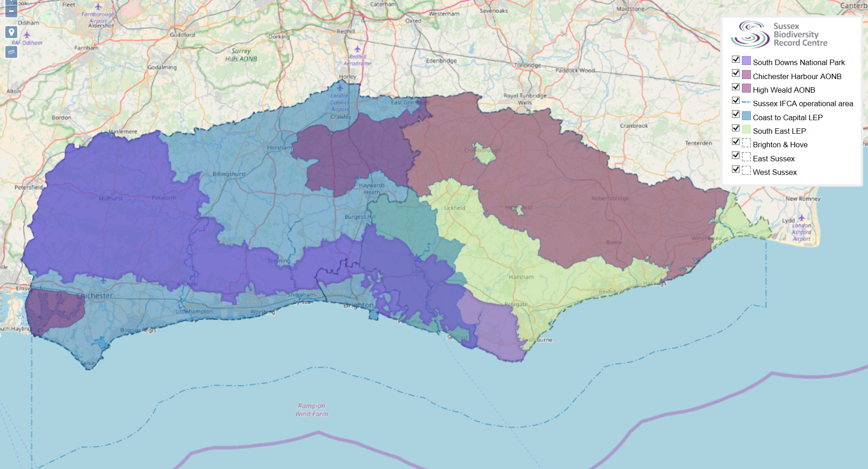

Role of the SxLNP
The overall purpose of an LNP is to:
- Drive positive change in the local environment, taking a strategic view of the challenges and opportunities involved and identifying ways to manage it as a system for the benefit of nature, people and the economy.
- Contribute to achieving the Government’s national environmental objectives locally, including the identification of local ecological networks, alongside addressing local priorities.
- Become local champions influencing decision-making relating to the natural environment and its value to social and economic outcomes, in particular through working closes with local authorities, Local Enterprise Partnerships and health and Wellbeing Boards.

Vision & Objectives

SxLNP Vision
The purpose of the Sussex Local Nature Partnership is to work across sectors and organisations to secure the healthiest ecological system possible thereby protecting and enhancing the natural environment and all that it gives us.
The vision will be the key guiding principle behind the work of the LNP, both in terms of direct delivery and in terms of any advice, statements and positions.
Natural Capital is the stock of our natural assets and is comprised of ecosystems (a dynamic complex of plant, animal and micro-organism communities and their non-living environment acting as a functional unit). The benefits that flow from this stock are often described as ecosystem services. Natural resources (such as food, timber and water) and functioning natural systems (such as healthy, fertile soils, clean water and air, and a regulated climate) are vital support services for our well-being and security, and are themselves sustained by biodiversity.
Growth of natural capital and improving the provision of ecosystem services therefore form the basis of the two overriding objectives of the Sussex LNP.

SxLNP Objectives
Consistent with this vision, the LNP has set two high-level objectives to determine the nature and trajectory of the LNP’s activities. These are:
1. Conserve, enhance and expand Sussex’s Natural Capital.
Growth in Natural Capital is the fundamental pre-requisite for enhancing the services provided by ecosystems and so underpins the economic and social well-being of Sussex. The LNP will promote the greening of the economy including the need to invest in nature because of the many benefits and essential services it provides.
2. Ensure that Sussex residents share in the benefits provided by healthy, well-functioning ecosystems.
The LNP will aim to improve the connection between people, their environment and the benefits they get from the environment. This will cover a broad spectrum of activities including health, well-being, social and economic areas.
To deliver growth in natural capital and share in the benefits of healthy ecosystems, the LNP will ensure that the evidence is collated to promote concepts, projects and initiatives that support the positive development of ecosystem services in Sussex. This will be shared across all sectors and audiences.

Structure & Governance

Structure
The Chair is the LNP’s figurehead. The Executive Board provides strategic oversight. The Board is informed by specific standing Task Groups and, if required, Task-and-Finish Groups. Information is drawn from a wider partnership made up of local residents, community groups and volunteers.

The Chair
- Role is to lead meetings of the Executive Board and to be the primary champion of the LNP. The Chair will maintain strong relationships with other senior leaders across the LNP area and beyond, and will represent the LNP at other relevant meetings.
- Principal duties and responsibilities:
  - build support for the vision and objectives of the LNP by acting as an influential advocate;
  - chair meetings, having regard for the agreed procedures of the Partnership, fulfilling these duties in a manner that is free from political influence or bias;
  - represent the Partnership, acting as a spokesperson at appropriate events, fora and meetings;
  - ensure a culture of mutual respect, partnership working and quality of opportunity for the Partnership;
  - ensure the views of the wider partnership are represented and taken into account during decision making to deliver integrated benefits for the natural environment;
  - support and assist the secretariat of the LNP.
- The Chair is elected by the Executive Board every year. There is no limit on consecutive terms. A Vice-Chair will also be elected to deputise for the Chair.

Executive Board
- The Executive Board is a non-constituted partnership of organisation representatives covering to spectrum of ecosystem services.
- The Executive Board will steer the Partnership and provide a strategic leadership and direction for the work of the LNP. It will be responsible for the following roles:
  - defining the strategic priorities of the LNP based on the agreed vision and objectives and operating principals;
  - further develop the LNP by reviewing and developing the purposes and operating principles ensuring that they remain relevant and reflect the views of the LNP and the local needs of Sussex;
  - monitor and evaluate the effectiveness and performance of the LNP in delivering integrated natural capital gains;
  - monitor, action and review progress against the LNP vision and objectives;
  - implement strategic decisions by developing delivery mechanisms;
  - support the LNP with knowledge, expertise and recommendations as required;
  - communication with the task groups to ensure effective working.
- Expectations and role of members will be to:
  - champion the work of the LNP to relevant partners, organisations and networks;
  - provide strategic input into the key decisions of the Executive Board relating to the vision, objectives and delivery plans;
  - actively seek opportunities to influence the strategy and plans of relevant organisations and groups to further the aspirations of the LNP;
  - represent and be accountable for the wider interests of their sector at LNP meetings;
  - operate in an open, responsive and accountable manner that adheres at all times to high levels of ethics and governance in public life.
- The Executive Board’s constituent organisations may change over time, and representatives may also change although continuity will be encouraged. The initial organisations represented are:
Sector | Organisations | Key ecosystem service links
Farmers & Land Managers | National Farmers Union  Country Land & Business Association | Provisioning  Support
Local Authority | Brighton & Hove City Council  East Sussex County Council  West Sussex County Council | Regulating  Support
Government Body/Agency | Natural England  Environment Agency  Forestry Commission  Inshore Fisheries & Conservation Authority | Regulating  Provisioning  Support
Protected Landscapes | South Downs National Park Authority  High Weald Area of Outstanding Natural Beauty | Support
Business | Southern Water | Provisioning
NGO | National Trust  Royal Society for the Protection of Birds  Campaign for the Protection of Rural England  Sussex Wildlife Trust  Woodland Trust  Action in Rural Sussex  Sussex Community Development Association  Arun and Rother Rivers Trust | Support Cultural
Research | Kew at Wakehurst  Sussex Biodiversity Record Centre | (Underpinning knowledge-base)
NUMBER | Approximately 25 individuals

Ways of Working
The Executive Board is formed in such a way as to encourage conversations and interactions to promote the emergence of ideas, thoughts and interactions which will then lead to actions. The strategy is therefore based on ground-up emergence rather than top-down governance. As a consequence, the Executive Board will be a large group consisting of individuals working at a high strategic level, who are committed to the LNP vision and aim to generate fruitful interaction.
The LNP Executive Board has a wide membership to enable fruitful discussions between people interested in a broad spectrum of ecosystem services. As representatives of various organisations, it is expected that members will have a diversity of views. The LNP, however, will need to function and offer clear advice against the background of individuals representing organisations with objectives that are different to those of the LNP. With the following ‘rules of engagement’ the LNP should be able to achieve some measure of consensus whilst recognising any organisational differences.
- The LNP Vision and Objectives form the guiding principles behind LNP actions, advice and statements. Executive Board members own and adopt these. Those who are uncomfortable about agreeing to this principle but still wish to engage with the LNP may feel it more appropriate to form part of the strategic network.
- Executive Board members may consider that whilst agreeing the Vision and Objectives, their organisation may not agree with all the detailed repercussions of such agreement. It is hoped that the member, and their organisation, will support the main thrust of the LNP whilst accepting minor differences.
- To partially address point 2, the LNP will aim to interact at a high strategic level offering advice and guidance on points of principle rather than points of detail. It may ask questions rather than make judgements (for example it may ask how a particular proposal delivers growth in natural capital rather than oppose it in the belief that it does not).
- There may be unusual situations were, even within the Aims and Objectives, there is no clear consensus between Executive Board members on an issue. In these situations it may be appropriate to represent the spectrum of opinions within the LNP. Whilst this could be valuable in some circumstances, if this happened too frequently then it would indicate lack of clarity from the environmental sector. This approach should therefore be kept to an absolute minimum.

Task Groups
- LNP task groups bring together experts in specific topics to take forward positive action within the LNP’s overarching vision and objectives.
- Task Groups are ultimately accountable to the LNP, but day-to-day operating methods are governed by each Task Groups respective ToR (where they exist).
- Task Groups provide updates (either verbal of written) at each LNP meeting.
- Current Task Groups:
  - Sussex Marine and Coastal Forum
  - Health & Wellbeing
  - Planning
  - Communications
  - Local Wildlife Sites
  - Natural Capital Investment Strategy.
- Any new Task Group must be approved by the Executive Board.

Secretariat
- The LNP Secretariat will administrate Executive Board meetings and distribute information. Until further notice, the Secretariat function will be provided on a no cost basis by ESCC.
- The Secretariat will maintain the LNP website in collaboration with the Sussex Biodiversity Record Centre.

Executive Board Meetings
- The Executive Board will meet quarterly in March, June, September and December with meeting dates set at the end of the preceding calendar year. The quorum for meetings is five members. Guest attendance is at the Chair’s discretion.
- Proposals for agenda items must be provided to the secretariat at least three weeks before the meeting. Their inclusion is at the Chair’s discretion. Items not on the agenda may only be allowed at the Chair’s discretion.
- Meeting papers will be circulated electronically by the secretariat at least one week before the meeting.
- Where members miss two consecutive meetings, the Chair may request their sector to nominate a new member.

Reporting mechanisms
The LNP operates independently and does not report to any specific body. It does, however, provide updates to Defra as and when required, and LNP members provide updates to and from their respective organisations. A summary report outlining the work of the LNP will be produced annually.

Review of ToR
These terms of reference will be reviewed every two years and approved by the LNP Executive Board.

Defra, 2012. An overview of the Local Nature Partnership Role.
HM Government, 2011. The Natural Choice: securing the value of nature.

